JOB DESCRIPTION
 |  | 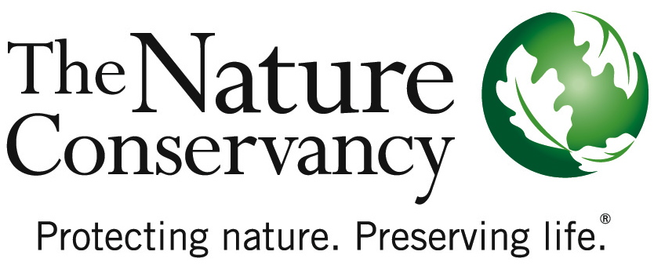
POSITION TITLE | Fisheries Scientist
JOB TITLE | Applied Scientist 2
JOB FAMILY | Science
JOB NUMBER | 400006
SALARY GRADE | 7
STATUS | Salaried
LOCATION | California: Monterey, Santa Cruz, Morro Bay or negotiable
DATE | June 15, 2016
SUMMARY | The Fisheries Scientist provides technical and scientific leadership for The Nature Conservancy’s California Oceans Program engagements in marine fisheries, including leading scientific efforts to assess and improve sustainability of state and federally-managed fisheries, advance fisheries science and information sharing systems, and support conservation and management of California’s marine ecosystems and resources. S/he leads all aspects of scientific investigation and collaborative research to support fisheries reform and conservation including: identifying and addressing science questions that most limit conservation; fundraising; convening partners; conducting research and data analysis; and, communicating results to broad audiences, including via peer-reviewed scientific journals.
ESSENTIAL  FUNCTIONS | The Fisheries Scientist helps to establish the Conservancy as a leading fisheries conservation partner by developing scientific projects, products, and collaborations that support marine conservation efforts in and beyond California’s state waters. The Fisheries Scientist builds scientific and technical capacity in the field and serves as a principal contact to fishermen, government agencies, other conservation organizations, foundations and the academic community. S/he works directly with these partners to lead collaborative research and scientific assessments to promote innovative conservation solutions to restoring and managing fisheries in California and around the world in line with the Conservancy’s global fisheries strategies. S/he works closely on multidisciplinary TNC teams to identify strategies to both improve fishery management decision-making and advance biodiversity conservation objectives. S/he leads multi-disciplinary teams, secures funding, manages grants and contracts, leads field research teams and partners, manages data, performs quantitative analyses, submits peer-review publications and reports, and communicates fishery science to broad audiences.
RESPONSIBILITIES & SCOPE | - Develops and leads fishery science projects and strategies to achieve conservation and fisheries goals.  - Provides thought-leadership in one or more critical area(s) of fisheries science.  - Builds relationships, partnerships and cooperation with outside parties to accomplish science program goals.  - Establishes the Conservancy as a leader in fishery science and marine conservation.  - Communicates science through presentations, publications, media, and outreach.  - Ability to convene and lead meetings with diverse partners to achieve objectives.  - Secures funding, manages grants and contracts.  - Frequently makes independent decisions based on analysis, experience and judgment.  - Must be able to work in variable weather conditions, at remote locations, on difficult and hazardous terrain and under physically demanding circumstances.
MINIMUM QUALIFICATIONS | - MS in fisheries science or related field and 2 years of experience or equivalent combination of education and experience.  - Extensive knowledge of current trends and practices in fishery science and management.  - Experience managing complex or multiple projects, including staffing, workloads and finances under deadlines.  - Experience developing partnerships at federal, state, and local levels.  - Strong quantitative skills in fishery science.  - Record of peer reviewed publications and other types of science communication.  - Valid driver’s license and willingness to travel throughout CA.
PREFERRED KNOWLEDGE, SKILLS & EXPERIENCE | - PhD in related science field and 1-3 years of experience in fisheries science and or marine ecology.  - Experience designing and leading multiple fisheries science projects.  - Experience manipulating, analyzing, and interpreting statistical, fisheries, or environmental data.  - Experience performing independent research in one or more of the following areas: data limited stock assessment, spatial modeling, aquaculture research, gear research, climate impacts on fisheries, marine spatial planning, marine pollution research, emerging ocean uses, citizen science, alternative gear research, bioeconomic modeling.  - Experience collaborating with fishermen, industry representatives and other partners.  - Demonstrated experience in fundraising and/or public and private grant writing.  - Ability to communicate effectively via written, spoken, and graphical means to broad audiences.  - Strong knowledge of common software applications and/or programming languages in fisheries science.

ORGANIZATIONAL COMPETENCIES | Accountability for Outcomes | Pushes for excellence. Establishes challenging goals for self and others to drive performance in support of the Conservancy’s mission. Rewards behavior that achieves these standards and is aligned with the organization’s mission/ values. Takes action to address performance problems in a timely and appropriate manner.
 | Builds Organizational Capability | Builds or adapts organizational structures to accomplish the mission and to improve performance. This includes reorganizing organizational systems, structures, processes, procedures, communication channels or reporting relationships. With the Conservancy’s strategic filter in mind, determines who can contribute, gets the right people involved, and builds bench strength for the future.
 | Collaboration & Teamwork | Shows a willingness to put the needs and goals of a global organization before personal/local/departmental needs. Works with others across organizational boundaries. Makes decisions, sets priorities, and allocates resources to help the organization as a whole achieve results.
 | Communications | Effectively expresses messages verbally and in writing. Actively listens to others. Fosters open exchange of issues. Is timely with information.
 | Courage & Decisiveness | Makes decisions and stands by them. Makes timely decisions even under pressure and when lacking complete information. Has the courage to modify decisions and admit why and how they were wrong.
 | Flexibility & Innovation | Flexible to changing circumstances. Takes innovative approaches towards work. Takes calculated risks and makes dependable decisions in the fact of uncertainty.
 | Influences for Results | Achieves results by persuading, convincing, or influencing others. Adapts approach to the individual or group and knows how and when to use complex influence strategies. Uses success stories and passion for the mission to generate enthusiasm and support.
 | Open to Learning | Versatile learner and committed to self-improvement. Employs strengths effectively. Willingly shares knowledge with others. Seeks coaching on areas needing improvement. Adjusts behavior/performance as needed. Views mistakes as learning opportunities.
 | Organizational Awareness | Understands the basics of our business. Knows how local job relates to the big picture & contributes to the overall strategy. Knows how/why things work inside TNC. Easily moves through internal networks and channels for success.
This description is not designed to be a complete list of all duties and responsibilities required for this job.

