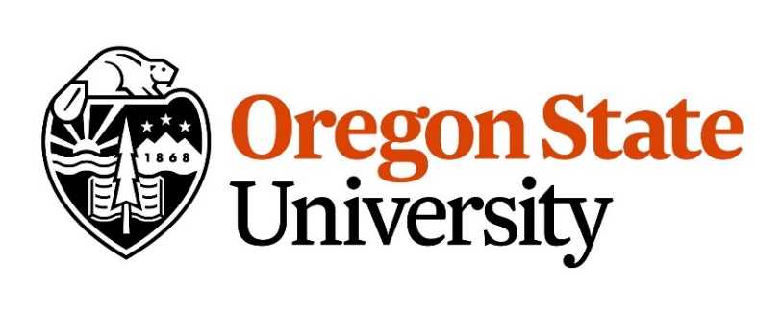

Postdoctoral Scholar Position in Salmon Ocean Ecology

Oregon State University, Newport, OR

It is widely recognized that the first period at sea for Pacific salmon is when they experience high levels of mortality and recruitment is often set. Yet, we understand little about the mechanisms at play. The successful applicant will work with an interdisciplinary team of oceanographers, salmon biologists, and statisticians to elucidate processes modulating early marine survival within the Columbia River Estuary and the near coastal ocean of the Northern California Current. Research foci include size-selective morality, predator-prey interactions, and age and growth dynamics.

**The successful applicant will:**

- Plan and conduct ecological research on the biology and ecology of Pacific salmon in the Northern California Current.

- Work collaboratively on a multi-investigator project focused on the early ocean growth and survival of Columbia River juvenile salmon, especially as it pertains to interactions with predators.

- Conduct independent research within this program.

- Prepare research manuscripts for peer-reviewed journal publications.

- Present research at scientific conferences and public outreach events.

- Assist in the training of graduate and undergraduate students in thesis or dissertation preparation,

research methods, and computational/mathematical methods.

**Qualifications**

**Required:**

- Ph.D. in ecology, fisheries biology, fisheries oceanography, or a combination of these areas or a closely related field.

- Strong quantitative skills. Proficiency with R or similar statistical/programming language.

- Demonstrated ability to generate peer-reviewed scientific publications.

- Excellent written and verbal communication skills.

**Preferred:**

- Peer-reviewed publication record (commensurate with career stage) relevant to population modeling, individual-based models, mixed effects models, etc.

-Demonstrated experience and expertise in analysis of growth structures and geochemical analysis and interpretation.

-Strong interest in collaborative research.

**Position Available:** January 1, 2020 (open until filled)

The successful applicant will work Dr. Jessica A. Miller in collaboration with Dr. Brian J. Burke (NOAA Northwest Fisheries Science Center). The position is renewable annually on a fiscal year basis (as long as the postdoctoral scholar is within five years from receipt of their doctoral degree) and funding is available for 2 years. Modest travel budget included. Re-appointment is at the discretion of the Principal

Investigator and the OSU Office of Postdoctoral Programs. Stipend and benefits conform with postdoctoral scholar standards at OSU.

**Application:** For full consideration, apply by November 10, 2019. Applicants must send: (1) a letter of application to describe academic experience, qualification and interest in the position; (2) curriculum vitae; and (3) email addresses of three professional references Application materials should be sent to Dr. Jessica Miller at [Jessica.miller@oregonstate.edu](mailto:Jessica.miller@oregonstate.edu).

More information about postdoctoral scholar appointments at OSU can be found at <http://gradschool.oregonstate.edu/postdocs>.

We encourage applicants with creative and diverse perspectives to join our community.

Oregon State University is an Affirmative Action / Equal Opportunity Employer.