**Postdoc position**

**Research fellow in the Laboratory of Intensive Aquaculture**

|  |  |
| --- | --- |
| **University of South Bohemia in České Budějovice:** | **Faculty of Fisheries & Protection of Waters** |

**Basic Description of the Lab, Work Place**

**The Laboratory of Intensive Aquaculture (LIA)** of the FFPW USB is primarily focused on:

1. Research and development of new aquaculture methods supporting the aquaculture production of carnivorous fish species (pikeperch – *Sander lucioperca*; pike- *Esox lucius*, Eurasian perch – *Perca fluviatilis* and burbot – *Lota lota*) under controlled conditions.

2. Optimization of the reproduction in carnivorous fish by different types of GnRHa.

3. Monitoring of hormones in blood of carnivorous fish during pre-ovulating and ovulating phase.

4. Evaluation of effect of environmental factors and rearing conditions on the physiology and quality of gamets (sperm and eggs).

5. Optimisation in vitro egg fertilization in carnivorous fish.

6. Domestication process such as tool of intensive culture of carnivorous fish

7. Effect of fish domestication on the reproduction a growth performance.

8. Optimization of larval, juvenile and boodtock culture of carnivorous fish under controlled condition with the aim to achieve the increasing fish production.

9. Selection and breeding programme in pikeperch ensuring higher growth rate and production of cultured fish.

10. Lab members participate in teaching process of bachelor, magister and doctorate students at the FFPW USB.

11. The LIA is cooperating with wide numbers of fish producing companies either from the Czech Republic (Rybářství Nové Hrady, Klatovské rybářství, Švarc – fish production in warm water, Rybníkářství Hluboká and Rybářství Litomyšl, Fish farm Bohemia) or from abroad (Excellence Fish – Netherlands, Lont en s van Baaren fish farm – Netherlands, LucasPerch – France, Asialor – France, Irish Waters Perch – Ireland and Moneycarragh Fish Farm – Ireland).

12. Solid scientific cooperation is established with following research institutions in the Czech republic – The Academy of Sciences of the Czech Republic, Mendel University in Brno, Czech University of Life Sciences in Prague, Agricultural faculty of the University of South Bohemia in České Budějovice and T. G. Masaryk Water Research Institute in Prague; and with following research institutions abroad – Nancy University – France, Research Institute for Fisheries, Aquaculture and Irrigation – Hungary, University of Warmia and Mazury – Poland, University of Agriculture Krakow – Poland, Aquaculture Initiative – Ireland, Fishing Institute in Starnberg – Germany, Institute for Fisheries in Born/Darß – Germany, Institute of Marine Research in Bergen – Norway and Veterinary Medical Research Institute in Budapest – Hungary.

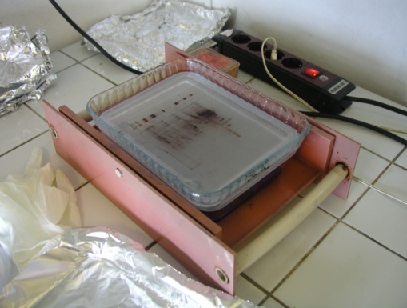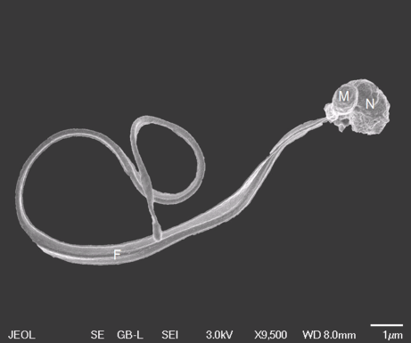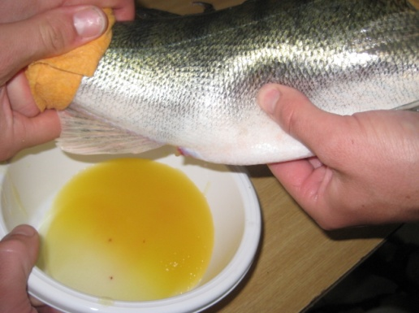

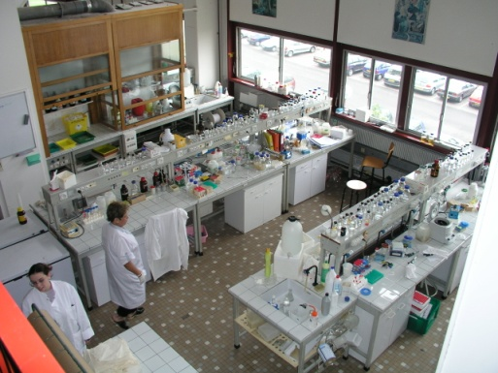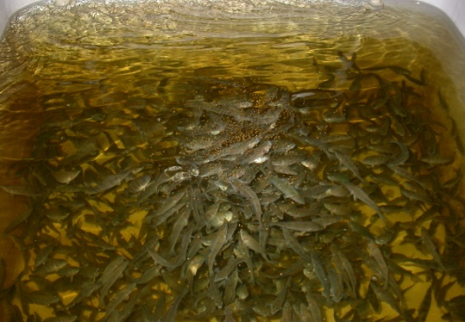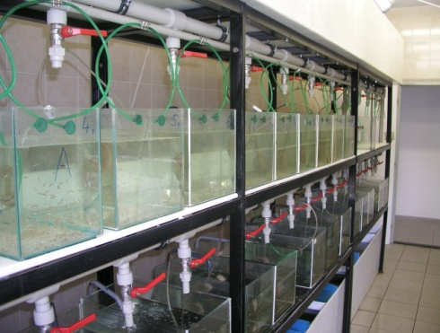

**The Contents of the Postdoc´s Work**

1. Evaluation of pikeperch reproduction under controlled conditions. Establishment of the domestication process in pikeperch.
2. Effect of domestication process on the reproduction of broodstock in pikeperch.
3. Breeding and selection program

– effect of broodstock strain on the juvenile growth and production in pikeperch,

– breeding selection of fast-growing fish for increasing pikeperch productivity.

1. Participation in other laboratory activities - the transfer of knowledge and methods of R & D work.
2. Participation on educational activities at the FFPW USB.

**The Selection Procedure**

**Specific Requirements**

1. The candidate successfully completed and obtained a Ph.D. degree or a similar degree if they studied abroad on or after March 29, 2008. In accordance with the conditions of the implementation body, the candidates with the Ph.D title from other universities than the University of South Bohemia in České Budějovice will be preferred.
2. Good knowledge of the Czech or the English language (CAE or the equivalent).
3. The minimum number of articles published in impact journals or other publications is 2 in a journal with IF>1 which were written during his Ph.D. studies. In these, the candidate is the first author. The candidate is an author and at least 3 publications where he is a co-author. Then at least 5 – 10 publication (depends on the year of completion of the Ph.D. degree) in a science journal with IF>1 which were written during the whole candidate´s carrier. (50%)
4. Interview by the evaluation commission (50%)

* Knowledge of the English language – will be checked through the interview (20%)
* Knowledge of the methods of gene expression analysis (e.g. RT-qPCR), histology of fish gonads or other tissues OR knowledge of LC/MS/MS (10%)
* The vision of the postdoc´s work in this workplace, motivation (20%) /

1. Study or working experiences in/from EU countries are appreciated.

**Necessary Documents**

1. CV
2. copy of the Ph.D. degree or similar degree if studied abroad
3. list of publications

Those candidates, who do not meet the above mentioned criteria, will be excluded from the selection procedure. Those candidates meeting these qualifications, will be assessed by a special evaluation committee (the second phase).

The assessment of the candidates will be performed according to the partial evaluation criteria and their rate for each partial evaluation criterion separately.

The most suitable candidate is the candidate, who obtains the most points.

**Term of the selection procedure**

To be officially opened in 7/2012.

**Form of employment**

Full time employment, place of work: The University of South Bohemia in České Budějovice

**Possible start**

9/2012, the contract is supposed to last for 34 months, until 30. 6. 2015.

**Salary**

40 000 CZK – 55 000 CZK/month

c. 1 600 EUR – 2 200 EUR/month

**More information on the Postdoc position by:**

**Assoc. Prof. Dipl.-Ing. Tomáš Policar, Ph.D.**

University of South Bohemia in České Budějovice

Faculty of Fisheries and Protection of Waters

Laboratory of Intensive Aquaculture

Head of laboratory

[policar@frov.jcu.cz](mailto:policar@frov.jcu.cz)

+420 387 774 606

+420 602 263 594

www:

<http://www.frov.jcu.cz/en/vurh-frov-ju/laboratory-of-fish-reproduction-and-intensive-culture-no-12-2>