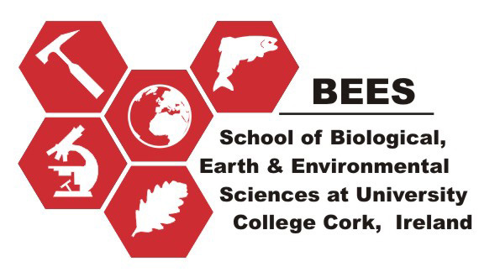

PhD Project Proposal
School of Biological Earth and Environmental Sciences, University College Cork
The health status of Southwest Irish waters in marine and
non-marine reserve areas

Recent work in South West Ireland has raised a number of concerns regarding the current health status of our coastal waters. Eutrophication from elevated nitrate levels both inside Ireland’s only nature reserve at Lough Hyne in West Cork and in the outside open waters have been recorded causing increased macroalgal blooms along the entire south west coastline, as well as an increase in red tides and toxic algal blooms both inside and outside of the marine reserve areas. Furthermore, increased bacterial counts around the southwest coastline in the summer of 2012 led to the closure of a number of County Cork’s blue flag beaches. Coastal industries such as aquaculture and fisheries may be directly or indirectly affected by these events. All of these incidents highlight a need for further investigation into the health status of our coastal waters and more importantly the potential consequences of these issues to marine communities.
The School of Biological, Earth and Environmental Sciences, University College Cork, Ireland, is offering this PhD position financed by the Crawford Hayes Fund. This award will include payment of annual EU fees and a yearly stipend (circa 16,000 euro p/a) for 3 years with a possibility to extend to four years. The project will be supported by a budget for consumables, equipment and travel. Minimum requirements for applicants will be an upper 2nd class Honours degree in an appropriate biological discipline. Relevant professional experience or relevant MSc degree experience will be an advantage.
Suitably qualified persons are asked to submit a completed CV with transcripts of their previous degree/s, names and contact details of two academic referees. In addition, applicants should also explain in a cover letter why you wish to undertake this PhD and how they might investigate this topic within the boundaries of available resources. Applications (letter plus CV) should be sent to The School of Biological, Earth and Environmental Sciences, University College Cork UCC, Enterprise Centre, Distillery Fields, North Mall, Cork. E-mail address: (bees@ucc.ie) FAX 353-21-4904664 to arrive no later than 5pm on Wednesday 27th February.
Interviews will be held on Friday 15th March.

For further details please email: Dr Rob McAllen (r.mcallen@ucc.ie), Dr Sarah Culloty (s.culloty@ucc.ie) or Dr Ruth Ramsay (r.ramsay@ucc.ie).

